Synthesis and Characterisation of Novel Antimalarial Triazolopyrazine Analogues

Talented Students Program Semester 2 2015

Chemistry Department University of Sydney

Thomas York – Christina Xia – Benjamin Xie

**1: Abstract**

Triazolopyrazine molecules have been shown to have a biological activity against Plasmodium parasites. This project saw the synthesis of 6 novel triazolopyrazine analogues to combat the emerging drug resistance in Plasmodium species responsible for malaria. Optimisation of triazolopyrazine analogues currently involves lowering the metabolic clearance rates whilst maintaining the potency of the drugs. To lower metabolic clearance times the solubility of the molecules is aiming to be increased. The molecules synthesized featured a naphthalene, difluorobenzene or a benzodioxole group in the north-east region of the molecule and a phenylethyl group or pyridine group in the north-west. As these molecules are novel, they were fully characterized to gain further information about the newly synthesized analogues. The characterisation of the novel compounds confirmed the synthesis of the target molecules. Throughout the project an open source ideology was adopted meaning all data and information regarding the project was freely available. An online free-to-view lab book was kept to share this information and was updated as close to real time was possible.

**List of abbreviations**

TSP – talented student program of Sydney University through which this project performed

EtOAc – Ethyl Acetate

PIDA – Phenyliodine diacetate

HRMS – high resolution mass spectrometry

DCM – dichloromethane

CLogP – the logarithm of the partition coefficient between 1-octanol and H2O

DMSO – dimethyl sulfoxide

ACT – artemisinin combination therapy

CRO – contracted research organisation

NMR – nuclear magnetic resonance

**2: Aims**

The project had two predominant aims:

1. The synthesis and categorisation of 6 novel molecules with antimalarial potential.
2. To examine the effects on solubility and activity of altering the functional groups in the north-east region of a triazolopyrazine core. More specifically, examine the effects associated with introducing naphthalene, difluorobenzene and benzodioxole functional groups.

**3: Background**

Malaria is one of the world’s oldest diseases with the earliest reported symptoms of such a disease first noted in 2700BC and still affects almost half the world’s population today. The highly dangerous disease is caused by the introduction of plasmodium strain parasites to the bloodstream, transmitted to humans from the female mosquito1. The life cycle of this parasite begins when the female mosquito feeds from the human, injecting the parasites in the form of sporozites into the human bloodstream. In the bloodstream, the sporozites aggregate and mature in the liver before exiting back into the bloodstream, invading the red blood cells and proceeding to replicate. Replication results in thousands of parasite-infested cells which ultimately causes the illness and symptoms of malaria such as fever, chills and sweating. If not treated, the aggregation and damage to the red blood cells will impair organ function and potentially impede blood circulation, resulting in death.

In 2013, there were 200 million reported cases of malaria and 584000 deaths with children under the age of 5 accounting for 78% of all deaths. Over 3.3 billion are described as being “at risk” of infection with estimates that over 90% of malaria infections and death are located in Africa2. These are alarming figures and the fact that there are over 25 malaria drugs now available, we must question why it is that the infection and mortality levels are so high. Currently one of the most widely used anti-malarial drug groups is artemisinin, first discovered in 1967 by Chinese chemist Tu Youyou3. However, as the usage of this drug increases, researchers have discovered issues regarding resistant strains and hold concerns for the future of anti-malarial drugs.

As artemisinin resistant strains emerge from the widespread use of the drug, intervention is key in preventing eventual treatment failure. Furthermore, artemisinin is used in combination with another partner drug in artemisinin combination therapy or ACT. Thus, it is increasingly important to ensure that the parasite does not similarly develop resistance to the partnered drug4. As a result, the World Health Organisation is beginning to develop a ban on the oral administration of ACT drugs 5. This emergence of resistant strains presses the need for further research into anti-malarial drug discovery. In doing so, researchers also hope to combat another previous drawback: the cost of ACT. Considering the low socioeconomic conditions in countries that malaria affects most, there is increased pressure to find new and affordable medicines that are less than 1 USD per dosage. Most importantly, new anti-malarial drugs must be developed to ensure the plasmodium parasite does not become increasingly resistant to strains of artemisinin. However, an implication of this is that major pharmaceutical companies no longer feel the market incentive to invest in new anti-malarials, calling upon the need for Open Source Drug Discovery to discover collaborative ways to find new treatments.

**3.1: Open Science**

Open science in its most fundamental state is the practice of sharing information and ideas and can be further expanded to encourage participation and involvement in ongoing research6. This open approach has the potential to accelerate research and more quickly solve research challenges via the involvement of relevant experts7. The availability of research from an open science model ensures integrity of work, due to open peer evaluation and mitigates unnecessary replication of research6. Because of the potential advantages associated with such a methodology, open science is being applied to drug discovery8,6 and being further codified and developed in chemical research9.

**3.2: Drug Discovery Considerations**

General constraints and considerations for drug discovery were also analysed prior to the design of the target analogues. The ‘rule of 5’ designed by Chris Lipisnki was used as guidelines for our drug discovery project, revealing a set of desirable qualities of bioactive compounds9. These include:

1. There must be no more than 5 hydrogen bond donors in the molecule. This is expressed as the sum of OH and NH groups in the molecule.
2. The molecular weight must be less than 500 daltons.
3. The Log P value must be less than 5. Log P value describes the partition coefficient between octanol and water, reflecting the hydrophilicity of the compound.
4. There must be no more than 10 hydrogen bond acceptors. This is expressed as the sum of N and O atoms in the molecule.

Conformation to these desirable qualities will result in good absorption and likely good permeation of the molecule into the human body when administered orally. This set of guidelines was taken into consideration for the target molecules, ensuring that all guidelines were observed in conjunction with original aims.

**3.3: Series 4**

The focus of this TSP Project was to synthesise anti-malarial analogs containing the triazolopyrazine group. Analogues of the triazolopyrazine core comprise series 4, an area of current research and optimisation.

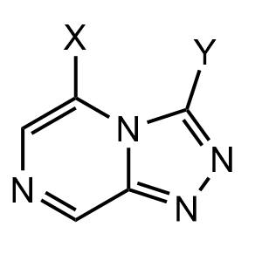

(Figure 3.3.1 – Triazolopyrazine core with organic groups X and Y to be substituted)

Data has been acquired for this molecule as triazolopyrazine compounds were initially discovered and researched by the pharmaceutical company Pfizer. After this project was discontinued, the information and research data was transferred to the Medicines of Malaria Venture group who employed contracted research organisation CRO to further investigate the potential of the triazolopyrazine series to form an effective and viable anti-malarial. Further research responsibility has been adopted by the Open Source Malaria team at the University of Sydney, lead by Associate Professor Matthew Todd. More specifically, research into the series 4 triazolopyrazine series is lead by Dr. Alice Williamson.

Analogs from the triazolopyrazine series have already displayed promising activity against the plasmodium parasite with low levels of cytotoxicity. An example is the analogue in Figure 2. This particular series 4 analogue has displayed an activity of 0.250 μM. Thus, a prominent motivation of this TSP project involved further research into the already promising series 4 antimalarial compounds in hope of synthesising more analogs through altering the triazole substituent in the north-east region.

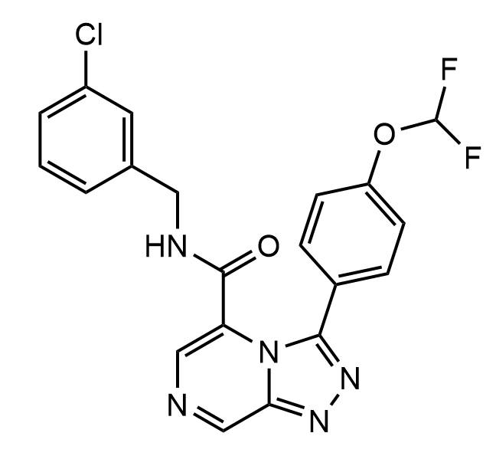

(Figure 3.3.2 – Series 4 analogue MMV668958, synthesised by MMV)

This optimization forms the basis of the research conducted by the OSM team regarding Series 4. Some of the objectives of this research include:

1. Improving metabolic stability – synthesising anti-malarials which are not processed or digested by the body before acting against the Plasmodium parasite.
2. Improving solubility – synthesising anti-malarials that can be more easily absorbed by the body.
3. Improving the two above factors whilst maintaining the potency and activity of the drug.

Anti-malarials within series 4 are of particular note as the specific mechanism of the triazolopyrazine based compounds in acting against the Plasmodium parasite has been researched and presented in an ion regulation assay involving active compounds. It has been suggested that the active triazolopyrazine analog inhibits the enzyme PfATP4 which is responsible for reducing and expelling sodium levels in the parasite. This disruption to the sodium homeostasis in the parasite causes intolerable change in acidity and pH which kills the malaria parasite 10.

The research for this TSP project is focused on the exploration of triazolopyrazine analogues with specific investigation into the impact on the optimisation of the analog from the alteration of the north-east attachment of the molecule. This is a particular variation of a series 4 analog which has not yet been explored to a great extent and the discovery and uncovering of more information regarding the effects of this north-east group forms a major motivator for this research project.

Furthermore, modification of the triazole group on the north-east region of the final molecule has been already been conducted with a number of final analogues synthesized. Considering the major aim of improving solubility, a triazole aryl substituent with a cyclo(hetero)aliphatic group was attempted. Some molecules featuring this triazole substituent can be observed in Figure 3. However, a major discovery that was considered when choosing the substituents to be used in this synthesis project was that these heteroatom groups significantly lowered the biological potency of the analogue in comparison to a potent analogue containing the aromatic group as shown in Figure 4.

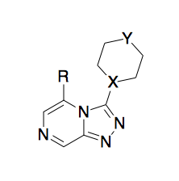(Figure 3.3.3 – General analogue with cyclo(hetero)aliphatic triazole substituent know to lower potency.)

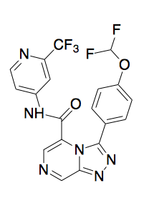

(Figure 3.3.4 – Analogue MMV670944 containing aromatic triazole substituent with known high potency.)

A number of organic groups were attached to this north-east portion including: difluorobenzene, naphthalene and benzodioxole. Further synthesis saw experimentation on also the north-west portion of the molecule with the initial phenylethyl group being substituted by a pyridine-2ylmethanol group whilst maintaining the same groups on the north-east portion as outlined above.



(Figure 3.3.5 – Scheme of proposed final analogues containing the difluorobenzene, benzodioxole and naphthalene triazole substituents with generic Ar group on the north-west portion of the molecule.)

**4: Results and Methodology**

Over the project an online lab notebook was maintained on LabTrove to record data and progress of the project11,12,13. The lab book was updated in real time to allow for collaboration from people outside of the project. The increasing usage of electronic lab notebooks is highly advantageous for an open source project as it has afforded easy sharing of data in real time on a free to view and interact platform14.

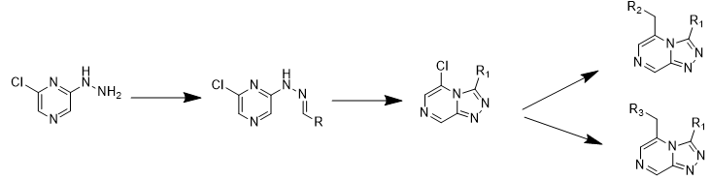

(Figure 4.1 – Scheme of all intermediates and final products numbered 1 to 12 as they are referred to in this section. Allocation of molecules are as follows: Thomas (1, 4, 7, 10), Christina (2, 5, 8, 11) and Ben (3, 6, 9, 12).)

2-chloro-6-hydrazinylpyrazine in ethanol previously synthesized by Dr Alice Williamson was reacted with a desired aldehyde to produce molecules **1** (93% yield), **2** (43% yield) and **3** (96% yield) in a condensation reaction. **1**, **2** and **3** in DCM were cyclized using PIDA twice to produce molecules **4** (76% and 27% yield), **5** (78% and 67% yield) and **6** (66% and 61% yield). **4**, **5** and **6** were purified via physical separation using DCM, NaHCO3, EtoAc and Brine and then recrystalised using EtoAc. Purified **4**, **5** and **6** in toluene were reacted with 2-phenylethanol in the presence of 18-crown-6 and KOH to produce **7** (50% yield), **8** (62% yield) and **9** (60% yield), which were purified by column chromatography. This reaction was repeated however with Pyridin-2-ylmethanol instead of 2-phenylethanol, this produced **10** (29% yield), **11** (23% yield) and **12** (18% yield).

**(*E*)-2-chloro-6-(2-(naphthalene-2-ylmethylene)hydrazinyl)pyrazine – 1**

2-chloro-6-hydrazinylpyrazine previously synthesised by Dr. Alice Williamson (4.00 g, 27.7 mmol, 1 equiv.) was dissolved in ethanol (approx. 200 mL) and reacted with 2-napthaldehyde (4.32 g, 27.7 mmol, 1 equiv.). Reaction proceeded at room temperature with stirring until TLC analysis (1:1 Hexane:petroleum ether) indicated reaction completion. Reaction mixture was dried under low pressure evaporation and the dried product collected**.** The final product was collected (7.28 g, 25.8 mmol, 93% yield).

**(E)-N-(2-(benzo[d][1,3]dioxol-5-yl)vinyl)-6-chloropyrazin-2-amine - 2**

Synthesis of (E)-N-(2-(benzo[d][1,3]dioxol-5-yl)vinyl)-6-chloropyrazin-2-amine by using the specific aldehyde benzo[d][1,3]dioxole-5-carbaldehyde (4.15 g, 27.7 mmol), in a condensation reaction. This was stirred in with 2-chloro-6-hydrazinylpyrazine kindly provided by Dr. Alice Williamson (4.00 g, 27.67 mmol, 1 equiv.). The reaction was left to stir overnight at room temperature. TLC analysis (1:1, hexane:petroleum ether revealed reaction had reached completion. Solvent was removed under a rotary evaporator and dried product was collected. No purification was carried out for this molecule. The final product was collected (3.67 g, 13.3 mmol, 43% yield).

**(E)-2-chloro-6-(2-(3,5-difluorobenzylidene)hydrazinyl)pyrazine – 3**

2-chloro-6-hydrazinylpyrazine (4.00 g, 27.9 mmol) and 3,5-difluorobenzaldehyde (3.93 g, 1 equiv.) were dissolved in ethanol (200 ml) and stirred for 30 minutes at room temperature. The starting material was previously synthesised by Dr. Alice Williamson for use in this synthesis project. After stirring, TLC analysis was performed using a solvent system of 1:1 hexane and petroleum ether (16 ml total solvent). When viewed under UV light, no contents of the starting material were present in the reaction mixture lane, suggesting the reaction continued to completion. The final reaction mixture was then dried in a rotary evaporator under low pressure before removing and placing into small vials without purification for further analysis and reactions. The final product was collected (7.12 g, 26.5 mmol, 96%).

**5-chloro-3-(naphthalen-2-yl)-[1,2,4]triazolo[4,3-a]pyrazine - 4**

**1** (3.58 g, 12.7 mmol, 1 equiv.) was reacted with (Diacetoxyiodo)benzene (16.5 mmol, 1.3 equiv.) and dissolved in DCM (250 mL). TLC analysis (1:1 Hexane: petroleum ether) indicated reaction completion. Reaction was quenched with approximately 100 ml sodium hydrogen carbonate. DCM (100 mL) was added and the organic layer was collected. Ethyl acetate (50 mL) and brine (50 mL) were added and the organic layer was collected. Dried sodium sulfate was added until all water appeared removed and the liquid filtered from sodium sulfate. The solution was dried under low pressure before being recrystallised with ethyl acetate. Drying under high vacuum produced a crystalline solid. The final product was collected (2.69 g, 9.57 mmol, 76% yield) repeat synthesis yielded (1.0 g, 3.6 mmol, 27% yield). Mp 196.2-197.8OC; δH (200 MHz; CDCl3) 9.38 (s, 1 *H*), 8.18 (s, 1 *H*), 8.05-7.85 (m, 5 *H*) 7.76-7.50 (m, 4 *H*), 7.27 (s, 1 *H*); HRMS (ESI) 303.04075 ([M+Na]+), calcd. for C15H9ClN4Na+ 303.70153.

**3-(benzo[d][1,3]dioxol-5-yl)-5-chloro-[1,2,4]triazolo[4,3-a]pyrazine - 5**

The previously synthesised (E)-N-(2-(benzo[d][1,3]dioxol-5-yl)vinyl)-6-chloropyrazin-2-amine  (3.67g, 13.30 mmol, 1 equiv.) was stirred with PhI(OAc)2(5.56 g, 1 equiv.) with DCM solvent (200mL). Reaction was left to stir overnight at room temperature. Completion of reaction was confirmed TLC analysis (1:1, hexane : petroleum ether). For purification, reaction mixture was quenched with saturated sodium hydrogen carbonate (100 mL) then diluted with DCM (50 mL), frequent release of gas was required after addition of sodium hydrogen carbonate. The bottom organic layer was collected, containing the desired product. Ethyl acetate (50 mL) and brine (50 mL) were added and the organic layer was collected. Sodium sulfate (6 spatulas) was added to dehydrate the solution prior to filtration. Solvent was removed by low pressure on rotary evaporator. Intermittent sonication and heating were required for recrystallization, washing with cold ethyl acetate. Product was collected under a high vacuum in a Buchner funnel to yield a crystalline solid. First synthesis yielded product (2.83g, 10.3 mmol, 78%) and second round of synthesis yielded (2.37g, 8.62 mmol, 67%). Mp 189-190 OC. δH (200 MHz; CDCl3) 9.31 (s, 1 *H*), 7.86 (s, 1 *H*), 7.12 (s, 1 *H*), 7.12-7.06 (t, *J* = 12 Hz, 2 *H*), 6.94 (d, *J* = 7.8 Hz, 1 *H*), 6.10 (s, 2 *H*).

**5-chloro-3-(3,5-difluorophenyl)-[1,2,4]triazolo[4,3-a]pyrazine – 6**

The cyclisation reaction involved previously synthesised (*E*)-2-chloro-6-(2-(3,5-difluorobenzylidene)hydrazinyl)pyrazine  core (3.68 g, 13.7 mmol) and (diacetoxyiodo)benzene (4.41 g, 1 equiv.) as a catalyst. The reaction mixture was stirred at room temperature for 1 hour before TLC showed the reaction had proceeded to completion. The reaction mixture was quenched by sodium hydrogen carbonate solution (150 ml) and washed with DCM (50 ml) in a separating funnel. The organic product dissolved in the DCM which resided at the bottom of the funnel, allowing the separation of the organic and aqueous layers. This solution was induced by inverting the separating funnel which caused the release of gas. As a result, it was important to frequently release the pressure inside the flask to minimize risk of injury. The organic and aqueous layers were separated with the aqueous layer preserved for further purification and extraction of cyclized product. The solution containing the organic layer was dehydrated with sufficient sodium sulfate powder before being decanted into a round bottom flask and placed on the rotary evaporate for 1 hour at 40OC under low pressure. Recrystallisation quickly yielded a solid product and as a result the flask was removed from the evaporator and filtered using a Buchner funnel to produce the first batch of the cyclized product. The filtrate was evaporated until dry. To extract the second batch of product, evaporation failed to recrystallize the solid. As a result, cold petroleum spirits were introduced to induce crystallization before the flask was sonicated for 5 minutes. The solution was then filtered again using the Buchner funnel to produce the second batch of the same synthesis product. First synthesis yielded product (2.42 g, 9.08 mmol, 66% and second round of synthesis yielded (2.16 g, 8.38 mmol 61%). Mp 210 – 212 OC; δH (200 MHz; CDCl3) 9.37 (s, 1 H), 7.94 (d, *J* = 2.8 Hz, 1 *H*), 7.27 (d, *J* =2.8 Hz, 1 *H*), 7.19-1.02 (m, 3 *H*).

**3-(naphthalene-2-yl)-5-phenethoxy-[1,2,4,]triazolo[4,3-a]pyrazine - 7**

**4** (056 g, 2 mmol, 1 equiv.) in toluene (10 mL) was reacted with 2-phenylethanol (244 mg, 2.00 mmol, 1 equiv.) in the presence of 18-crown-6 (400 µmol, 106 mg, 0.2 equiv.) and KOH (393 mg, 7.00 mmol, 3.5 equiv.). The reaction mixture was heated to 40 OC and stirred until TLC analysis (7:3 EtOAc:petroleum) showed reaction completion. Reaction mixture was allowed to cool to room temperature and was diluted with water (4 mL). The reaction mixture was washed with Ethyl Acetate (3 x 10 mL) and the organic layer collected. The organic layer was then washed with water (4 mL) and Brine (3 mL). Dried Sodium Sulfate was added, until all water appeared removed and the liquid filtered from Sodium Sulfate and dried under low pressure. The crude mixture was purified via column chromatography using silica powder (50-80% Ethyl Acetate: Petroleum). Fractions containing the desired product were combined and dried under low pressure using liquid nitrogen coolant. H NMR analysis of the product was promising so full characterisation of the compound was carried out due to its novelty. The final product was collected (0.36 g, 0.98 mmol, 50% yield) Mp 182.6-183.6OC; δH (400 MHz; *d*-DMSO) 9.04 (s, 1 *H*), 8.31 (d, *J* = 1.0 Hz, 1*H*), 8.11–8.00 (m, 3 *H*), 7.82 (dd, *J* = 8.5 and 1.7 Hz, 1 *H*), 7.67–7.61 (m, 2 *H*), 7.57 (s,1 *H*), 7.03–­6.97 (m, 1 *H*), 6.91–6.86 (m,2 *H*), 6.56–6.51(m, 2 *H*), 4.46 (t, *J* = 6.3 Hz, 2 *H*), 2.73 (t, *J* = 6.2 Hz, 2 *H*); δC (101 MHz; *d*-DMSO) 148.7, 147.4, 146.7, 146.3, 144.1, 137.5, 135.1, 128.8, 128.4, 126.6, 125.4, 121.4, 111.4, 108.9, 107.7, 101.7, 71.4, 34.1; HRMS (ESI) 389.13701 ([M+Na]+), calcd. for C23H18N4ONa+ 389.40499.

**3-(benzo[d][1,3]dioxol-5-yl)-5-phenethoxy-[1,2,4]triazolo[4,3-a]pyrazine - 8**

For addition of phenylethanol onto the northwest side chain, previously synthesized 3-(benzo[d][1,3]dioxol-5-yl)-5-chloro-[1,2,4]triazolo[4,3-a]pyrazine (549 mg, 2.00 mmol) and phenylethanol (244 mg, 1 equiv.) Reagents used to aid SnAr reaction included Potassium Hydroxide KOH (7.0 mmol, 393 mg, 3.5 equiv.) and 18-crown-6 dissolved (400 µmol, 106 mg, 0.2 equiv. After stirring for 2.5 hours at 40 °C the reaction had reached completion as confirmed by TLC analysis (9:2, ethyl acetate:petroleum ether). Crude product was allowed to cool to room temperature and diluted with water (4 mL) purified by washing with ethyl acetate (3 x 10 mL) and organic top layer was collected. Organic layer was washed with water (4 mL) and brine (3 mL) and then dehydrated with sodium sulfate. Solvent was removed by lower pressure on rotary evaporator. An appropriate TLC solvent was then determined for this product, a 9:2 ethyl acetate: petroleum system yielded an Rf value of 0.186. The column purification carried out using an automatic column machine, separating the reaction mixture into fractions based on the absorbance levels at various wavelengths. This purification step yielded 1 fraction (test tubes 12 – 35), which were isolated and then solvent removed to yield the final novel anti-malarial. Synthesis yielded product (0.34 g, 0.12 mmol, 62%). Mp 162 – 163 OC**;** δH (400 MHz; *d*-DMSO) 8.98 (s, 1 *H*), 7.54 (s, 1 *H*), 7.27 (s, 1H) 7.19-7.15 (m, 4H), 7.03 (d, *J* = 12) 6.94-6.87 (m, 3 H), 6.05 (s, 2 *H*), 4.47-4.40 (m, 2 *H*), 3.03-2.97 (m, 2 *H*). δC (400 MHz; *d*-DMSO) 149, 148, 149, 147, 146, 138, 137, 130, 129, 127, 127, 112, 109, 108, 102, 71.8, 40.0, 34.4; HRMS (ESI) 383.11 ([M+Na]+), calcd. for C20H16N4O3Na+ 383.36.

**3-(3,5-difluorophenyl)-5-phenethoxy-[1,2,4]triazolo[4,3-a]pyrazine - 9**

Phenylethanol (244 mg, 1 equiv.) was stirred with triazolopyrazine core (2.0 mmol) and toluene (10 ml) at 40OC for 30 minutes using the KOH (393 mg, 7.00 mmol, 3.5 equiv.) and 18-crown-6 (37 mg, 140 μmol, 0.1 equiv.) as a catalyst system in the reaction flask. TLC analysis using a 100% ethyl acetate solvent mixture showed the reaction had gone to completion. The mixture was left to cool to room temperature before water (5 ml) was introduced to dilute the product to transfer into the separating funnel where it was washed three times with EtOAc (10 ml each time). The organic layer was run off and washed with water (4 ml) and brine (3 ml). Sufficient sodium sulfate was added to dehydrate the mixture and eventually removed via filtration. The remaining solution was evaporated using a rotary evaporator at low pressure. The final product was collected and analysed with TLC. This analysis proved difficult as a solvent mixture with appropriate polarity was required. Experimenting with different ratios of DCM, EtOAc and methanol were generally not polar enough to lift the product from the TLC baseline. The final solvent system used for 100% EtOAc. An automatic column was then used to purify the product mixture, observing the peak absorbance at individual wavelengths and collecting the filtrate in a rack of test tubes. Although, the solvent mixture was different to the initial crude product TLC as 1:1 EtOAc and petroleum ether was used. The solutions in the 1 fraction of 14 test tubes were then combined placed on rotary evaporation under low pressure to yield the analogue. Synthesis yielded product (319 mg, 1.20 mmol, 59.9%). Mp 172 – 173 OC. δH (500 MHz; *d*-DMSO) 9.10 (s, 1 *H*), 1.38 (s, 1 *H*), 7.47-7.40 (m, 7 *H*), 7.26-7.05 (m, 3 *H*), 6.85-6.9 (m, 4 *H*), 4.52 (t, *J* = 22 Hz, 2 *H*), 2.85 (t, *J* = 35 Hz, 2 *H*). δC (500 MHz; *d*-DMSO) 149, 148, 147, 147, 145, 138, 136, 129 ,128, 126, 125, 112, 110, 108, 103, 72, 40, 35; HRMS (ESI) 375.04 ([M+Na]+), calcd. for C19H14F2N4ONa+ 375.33.

**3-(naphthalene-2-yl)-5-(pyridine-2-ylmethoxy)-[1,2,4]triazolo[4,3-a]pyrazine - 10**

**4** (0.28 g, 1.0 mmol, 1 equiv.) in toluene (9 mL) was reacted with Pyridin-2-ylmethanol (110 mg, 1.0 mmol, 1 equiv.) in the presence of 18-crown-6 (27 mg, 100 µmol, 0.1 equiv.) and KOH (0.20 g, 3.5 mmol, 3.5 equiv.). The reaction mixture was heated to 40 OC and stirred until TLC analysis (100% EtoAc) showed reaction completion. Reaction mixture was allowed to cool to room temperature and was washed with EtOAc (3 x 15 mL). Organic layer was collected and washed with Brine (15 mL). Organic layer was collected and Magnesium Sulfate was added until all water appeared removed and the liquid filtered from Magnesium Sulfate and dried under low pressure. The crude mixture was purified via column chromatography using silica powder (100% EtOAc). 1H-NMR data and TLC analysis of the fractions showed they did not contain the expected product. The column was then washed with methanol 0-10% and DCM. The fractions showing the expected product on TLC were combined and dried under low pressure. 1H-NMR of the crude product was encouraging however the presence of solvent peaks and novelty of this product meant it was dried and fully characterised. The final product was collected (97 mg, 0.29 mmol, 29% yield). Mp 168.8-170 OC; δH (200 MHz; CDCl3) 9.10 (s, 1 *H*), 8.42 (d, *J* = 2.4 Hz, 1 *H*), 8.21 (s, 1 *H*), 7.94-7.67 (m, 6 *H*), 7.64-7.45 (m, 4 *H*), 7.10-6.84 (m, 2 *H*), 6.29 (d, *J* = 3.8, 1 *H*); HRMS (ESI) 376.11666 ([M+Na]+), calcd. for C21H15N5ONa+ 376.36647.

**3-(benzo[d][1,3]dioxol-5-yl)-5-(pyridin-2-ylmethoxy)-[1,2,4]triazolo[4,3-a]pyrazine - 11**

3-(benzo[d][1,3]dioxol-5-yl)-5-chloro-[1,2,4]triazolo[4,3-a]pyrazine (273 mg, 1.00 mmol, 1 equiv.) was stirred in pyridine-2-ylmethanol (109 mg, 1 equiv.) for 1.5 hours at 40 °C . Confirmation of reaction completion was assessed using TLC analysis (100% ethyl acetate). Crude product was allowed to cool to room temperature and diluted with water (4mL) purified by washing with ethyl acetate (3 x 10 mL) and organic top layer was collected. Organic layer was washed with water (4 mL) and brine (3 mL) and then dehydrated with sodium sulfate. Solvent was removed by lower pressure on rotary evaporator. Prior to column purification a new solvent system was determined, suiting the polarity of this new molecule. The solvent system of 90:9:1 ethyl acetate:methanol:ammonia solution returned a Rf value of 0.678. Three fractions were collected after column purification (test tubes 2-3, 4-5, 6-7) solvent was removed and each one individually assessed for the second novel antimalarial. Synthesis yielded (803 mg, 0.23 mmol, 23%). Mp 187 - 188 OC. δH (200 MHz; CDCl3) 9.04 (s, 1 *H*), 8.58 (d, *J* = 3.4 Hz, 1 *H*), 7.72-7.58 (m, 1 *H*), 7.38 (s, 1 *H*), 7.27-7.12 (m, 6 *H*), 6.87-6.8 (m, 2 *H*), 5.99 (s, 2 *H*), 4.78 (s, 1 *H*); HRMS (ESI) 370.09 ([M+Na]+), calcd. for C18H13N5O3Na+ 370.32.

**3-(3,5-difluorophenyl)-5-phenethoxy-[1,2,4]triazolo[4,3-a]pyrazine - 12**

Pyridin-2-ylmethanol (109 mg, 1 equiv.) was similarly stirred with the triazolopyrazine core (1.0 mmol) and toluene (10 ml) as solvent for approximately 20 minutes using the KOH (393 mg, 7.00 mmol, 3.5 equiv.) and 18-crown-6 (37 mg, 140 μmol, 0.1 equiv.) as a catalyst system in the reaction flask. To complete the TLC analysis and column purification, the solvent system used was 90:9:1 ethyl acetate:methanol:ammonia solution, revealing that the reaction had proceeded to completion. The reaction mixture was diluted with water (5 ml) before being washed four times with EtOAc (10 ml each time), preserving the organic upper layer each time as the aqueous layer was washed. Sufficient brine and magnesium sulfate were added before the mixture was filtered. The filtrate was transferred to a round bottom flask before being put in the rotary evaporator under low pressure. This crude mixture was purified through column chromatography using the 90:9:1 ethyl acetate:methanol:ammonia solvent system. Two fractions of test tubes 5-9 and 10-14 yielded absorption in the appropriate wavelengths, suggesting presence of the product in those fractions. The fractions were removed and collected for rotary evaporation under low pressure until a solid product was observed. Synthesized yielded (58 mg, 0.17 mmol, 17%) Mp 191-192 OC; δH (200 MHz, CDCl3) 9.06 (d, *J* = 4.6 Hz, 1 *H*), 8.58 (s, 2 *H*), 7.67-7.61 (m, 2 *H*), 7.50 (d, *J* = 3.8 Hz, 1 H), 7.25-7.23 (m, 8 *H*), 7.02-6.98 (m, 1 *H*) 6.98-6.85 (m, 1 *H*). δC (500 MHz; *d*-DMSO) 164, 161, 154, 150, 148, 145, 144, 137, 135, 132, 124, 123, 114, 114, 110, 106, 73, 40; HRMS (ESI) 362.01 ([M+Na]+), calcd. for C18H13N5O3Na+ 362.29.

**5: Discussion**

**5.1: Thomas York**

Product yields

Synthesis of molecules 1 and 4 gave satisfactory yields of 93% and 76% respectively. There was a large variation between the first and repeat synthesis of molecule 4 (76%- 27%) however this was due to mechanical loss rather than as a result of the methodology.

Yield variation between 7 and 10

Synthesis of **10** (29% yield) gave much lower yields than synthesis of **7** (50% yield) both of which underwent the same nucleophilic aromatic substitution of the chlorine atom from **4**. It is possible the difference in yield is due to the difficulties with the column purification of **10**. The first washings of the column produced several fractions which did not contain the expected product and as such the column had to be washed with a solvent solution of increasing methanol (0-10%) and DCM. It is possible that this difficulty in separating column fractions was due to the low Rf value (0.11) obtained with the solvent system (100% EtOAc). The Rf value obtained with molecule **7** and the solvent system for its column purification (increasing EtOAc 50-80% and petroleum) was approximately 0.17.

The column fractions of 10 and 7 were analysed via TLC and only fractions showing no starting mixture and a strong UV absorbance at the expected Rf for **10** were kept. It is possible this highly discerning separation left more of 10 in fractions containing starting mixture, whereas **7** due to its higher Rf value more easily separated into starting material and product.

The low yield is likely not entirely due to poor column purification however as the starting fractions which were analysed via H NMR to determine if product was present showed unreacted pyridin-2-ylmethanolH.

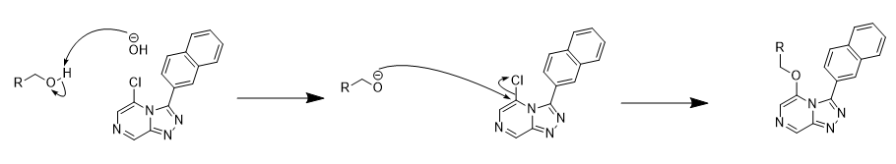

**Scheme 1: Proposed mechanism for the nucleophilic aromatic substitution.** Mechanism to produce molecules **7** and **10**.Reaction occurs in toluene with an 18-crown-6 catalyst which complexes with K+ and thereby brings the K+ and the OH- into the organic phase where the OH- acts as a much stronger nucleophile than OH- in water15.

Literature reports involving different reactions with pyridin-2-ylmethanol and 2-phenylethanol acting as nucleophiles have shown distinctly differing yields between the two reagents. A particular study involving the two reagents being used in a Fischer–Porter produced yields of 96% (pyridin-2-ylmethanol) and 68.8% (2-phenylethanol)16. The result from literature is inconsistent with those demonstrated in this project this indicates that perhaps the variation in yield is not due to the ease with which reagents form nucleophiles. Whilst parallels can be drawn between the reaction in this study and the one cited this is by no means conclusive.

The lower yields of the pyridin-2-ylmethanol is surprising as it is expected to form a stronger nucleophile due to the reduced separation between the alcohol group and the aromatic carbons and the additional lone pairs in the heterosubstituted benzene. Improvements to this yield may be obtained by using a solvent system with a high Rf value for column purification. This will also be useful in determining if this is a large factor in the lower yield.

**Spectroscopic confirmation of products**

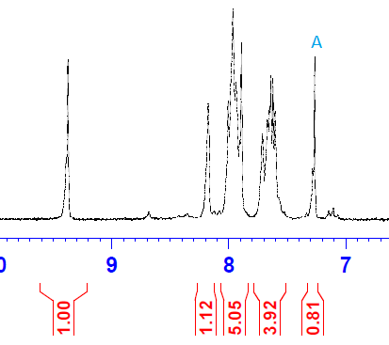Molecule 4

H NMR of **4**, produced a spectra showing 3 too many protons, 1 of these can immediately be discounted as the peak produced from the residual non-deuterated chloroform, peak A. The shifts of the rest of the peaks are those expected of aromatic hydrogens. 2 of the peaks are singlets which is also expected however the low resolution of the NMR machine (approximately 200 MHz) makes it impossible to confidently determine the shape of the other peaks. This low resolution is most likely why the integration values appear too high, there are many hydrogen environments with similar expected shifts which have been super imposed due to the low resolution.

HRMS of **4**, (303.04075) gave the correct mass of the molecule plus sodium (303.70153). The variation between the two value is most likely due to chlorine which occurs with a mass of 37 approximately 24% of the time. This means the average mass is higher than the mass of the most common isotope in the HRMS reading. Therefore this value provides evidence for the correct synthesis of our target molecule.

The HRMS confirmation of the mass of **4** being equal to the expected means it is likely the molecule is the target molecule and the integration values are simply due to the low resolution of the NMR machine. Also the appearance of the two singlets with highest shifts are very encouraging as these are expected of the aromatic protons on carbon atoms situated next to a nitrogen or chlorine. To have certainty that **4** was indeed synthesised high resolution carbon and hydrogen NMR will need to be taken and analysed.

Molecule 7

The high resolution H NMR data for **7** strongly indicates that the target molecule was synthesised. It shows 14 aromatic protons as expected with the correct shifts and 4 aliphatic protons occurring in two sets of triplets. The high resolution C NMR showed 18 carbon environments, 16 aromatic ones and 2 aliphatic. There should be 21 unique carbon environments in **7** however the naphthalene group is likely to have carbon environments which are very similar thereby appearing to contain less than expected.

HRMS of **7** recorded 389.13701 and as the expected mass for **7** plus sodium is 389.40499 this measurement agrees with the predicted value. Therefore there is a high degree of certainty that **7** was successfully synthesised.

Molecule 10

The H NMR for **10** contains solvent peaks for DCM, methanol, EtoAc and the residual chloroform. The large peak for DCM obscures the area where the aliphatic protons are expected. The peak around 5.3 ppm which corresponds to DCM is slightly wider than expected suggesting that the aliphatic protons are underneath this peak. The integration of the aromatic protons adds to give 14 which is one more than expected. This is likely due to the superposition of the residual chloroform peak with aromatic protons. Therefore whilst certainty cannot be assured in a spectra with so many solvent peaks and poor resolution of the aromatic protons it is likely the spectra belongs to the target molecule. Also the characteristic signals of the singlet above 9 ppm which is in molecule **4** is still there and with extra aromatic signals from the addition of the pyridine strongly suggest the reaction proceeded as expected.

HRMS of **10** was measured at 376.11666, given the mass of **10** with sodium equals 376.36647 it is very likely the molecule synthesised is the target molecule. Further confirmation will come from analysis of carbon and hydrogen high resolution NMR.

Solubility and potency

The measurements of molecules **7** and **10**’s potential for success as antimalarials is determined by their potency and solubility. These are yet to be determined and the results of these will determine the future of this molecule and similar molecules. This will also determine if the aim of this investigation was achieved.

Conclusion

Spectroscopic data has shown certain synthesis of **7** and a high likelihood that **4** and **10** were successfully synthesised. Certainty is limited by the analysis of only low resolution NMR data for **4** and **10**, further higher resolution spectroscopic analysis will confirm synthesis. Therefore the first aim is likely successful seeing the synthesis of 2 novel naphthalene compounds and will shortly be confirmed. Determining the potential success of these compounds as antiamlarials will come from measuring their activity and solubility and thereby fulfil the second aim of this project.

**5.2: Christina Xia**

Synthesis of Molecule 2 – condensation reaction

The condensation reaction involves the benzodioxole aldehyde attaching to the northeast, of the molecule. The presence of peaks at both 1320–1000 cm-1 and ~1600 cm-1 in the IR spectra indicate formation of C-O bonds and C=N, respectively, is able to characterise that the formation of the correct molecule, due to the fact that presence of the only C=N bond, serving as the linker between the aldehyde and in condensation reaction, indicates formation of desired molecule. C-O stretching occurs over large band, thus easily able to be recognised , however for molecules 8 and 11 we are not able to characterize formation of ether C-O bonds in addition of pyridinylmethanol and phenylethanol in north east, as C-O stretching is already present due to the benzodioxole group.

Synthesis of Molecule 5 – cyclisation reaction

Synthesis of molecule occurred 2 times. However interesting outcomes included the two extremely different colour of the same compound – first synthesis yielding a pale yellow powder and second round of synthesis of dark red powder. It is possible the disparity in colour is only due to a minor contaminant, resulting in very different colours. However comparison from the two NMR results, able to confirm that both are correct compounds formed. A total of 7 peaks corresponds to 7 hydrogen environments in the molecule. The integrals agree for synthesis of both the samples, however they do not exactly correlate to correct number of hydrogens, due to the resolution of the 1H NMR.

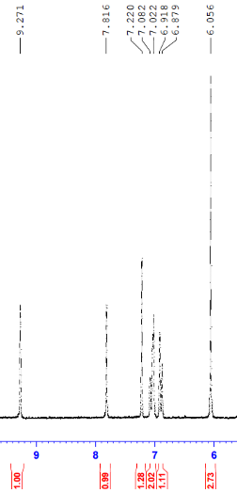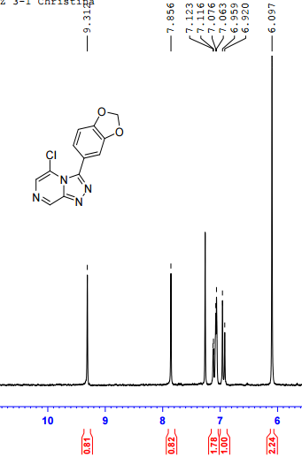

(Figure 5.2.1 – 1H-NMR spectra of initial and repeat synthesis)

Synthesis of Molecule 8 & 11 by SNAr

The difficulty in collection of correct product for molecule 11, is evident as not the most appropriate solvent system was selected (solvent system of 90:9:1 ethyl acetate:methanol:ammonia), the TLC plate for compound 11 separated into several tightly spaced bands. As the results from TLC will carry over to the column purification, it gave rise to 3 small fractions that had to be collected and purified. In comparison to compound 8, the TLC plate with a 9:2, ethyl acetate : petroleum system formed 2 clear distinct bands, and also column purification resulted in one fraction.

It is possible that this explains why the yield for molecule 11 is very low – 23%, in comparison to other previous reactions, where significant amount product was not able to be collected in column purification, as the polarity of the compound did not suit the solvent system well.

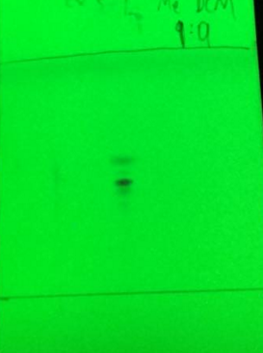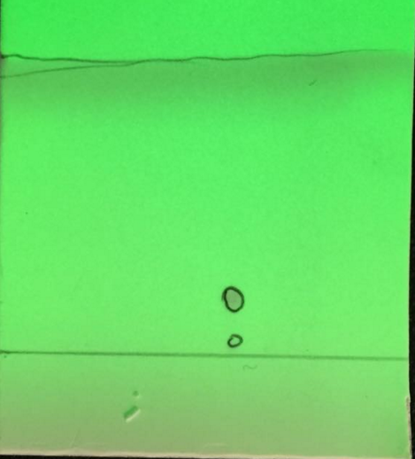

(Figure 5.2.2 – TLC for column purification of molecules 8 and 11)

The target molecules were characterized using a combination of HRMS and NMR spectroscopy. The molecular weight from HRMS affirms the estimated molecular weight of compounds of molecule 8 (383 g) and molecule 11 (370 g). From its high level of accuracy it can be confirmed that the correct atoms are on the molecule. The high-resolution 13C NMR for molecule 8 is able to illustrate the correct number of carbon environments of a total of 18 carbons, situated throughout the molecule. For 1H NMR spectroscopy for Molecule 11 it returned correct number of 4 aliphatic protons and 9 aromatic protons. However the summation of the integration values, reflected a total of 16 in comparison to the expected 13, due to the low resolution of NMR data.

Conclusion

New novel molecules containing the triazolopyrazine core were successfully synthesised over the course of this project. However data on solubility and metabolic solubility, as well potency has yet to be obtained for in vivo scenarios. This data will be able to determine the success of our molecules as an anti-malarial drug. Overall it was a successful research project, resulting in the possibility of divulging into many promising leads into future research.

**5.3: Ben**

Condensation Reaction

The condensation reaction resulted in the production of (E)-2-chloro-6-(2-(3,5-difluorobenzylidene)hydrazinyl)pyrazine – molecule 3. A very high yield of 96% by mass was recorded, possibly resultant from the reaction being allowed to go to completion during synthesis. The reaction occurs due to the nucleophilic and electrophilic interactions between the aldehyde and nitrogen atom on the hydrazinylpyrazine molecule. Regular TLC measurements were taken to ensure that no trace of starting material remained in the reaction mixture. However, no characterization of this product was performed and as a result there is a possibility there were contaminants contributing to the high mass yield of the product. Assuming the first intermediate molecule 3 was pure, the high yield of this reaction may have a significant commercial and industrial impact should this anti-malarial ever go to production. With a good yield produced without any purification steps such as column chromatography, a significantly time, cost and energy consuming step of large scale synthesis could be avoided with the knowledge that if the reaction is allowed to go to completion, a high yield of product can be achieved. Further characterization of the molecule should be undertaken in the future to validate these assumptions and ensure the synthesis of the correct product. IR spectroscopy was used to characterize this intermediate, identifying C=N and C-N bonds with absorbances in regions of 1600 and 1100 respectively. Purification of the compound may decrease yield but ensure purity of the intermediate when moving forward to the cyclisation reaction.

Cyclisation Reaction

The cyclisation resulted in the product 5-chloro-3-(3,5-difluorophenyl)-[1,2,4]triazolo[4,3-a]pyrazine – molecule 6. Repeat synthesis of this intermediate was performed with the initial iteration yielding 66% and second iteration yielding 61%. A consistent yield was observed for both reactions however the relatively low yield may be attributed to the evaporation techniques employed to extract the recrystallized product following the work up. For both iterations of synthesis, the solid product recrystallized at an initial fast rate when placed on the rotary evaporator and subsequently quickly removed and filtered to extract this product. As a result, this may have disrupted the recrystallization of further product in the filtrate. The filtrate was then again placed under low pressure evaporation however the extraction of the solid product was more difficult for both iterations of synthesis, requiring sonication and cold petroleum spirits. As a result, it is possible that some product was remaining in the discarded filtrate. Further improvements to the methodology involve a more efficient method of extraction in comparison to the Buchner funnel from which some product could not be extracted.

1H NMR spectroscopy was used to confirm the successful production of the product with the correct number (5) of protons determined through the integration values. The appearance of two relatively high shifts on the spectra affirms the presence of the aromatic ring in our final compound, providing evidence for the formation of our target molecule. As this spectra was taken with a relatively low resolution of 200MHz, it is likely that hydrogen environments may appear clustered and grouped, making it difficult to discern the shape of the shifts.

IR spectroscopy was also used to determine the presence of a number of different bond types present in the molecule. The common C=N and C-N bonds present in the core of the cyclized molecules are reflected by absorbance in bands at regions 1600 and 1100.

HRMS was also used to confirm the synthesis of the desired product. The expected mass of 289.62 of the molecule with sodium was reflected by the HRMS result of 288.94. The discrepancy can be explained by the presence of isotopes of fluorine or chlorine. Therefore, the results of this HRMS analysis, IR and 1H-NMR analysis reveal the successful production of the desired compound.

Nucleophilic Aromatic Substitution Reaction

Two final anti-malarial analogues were synthesized from the cyclized product 6 to form 3-(3,5-difluorophenyl)-5-phenethoxy-[1,2,4]triazolo[4,3-a]pyrazine – molecule 9 - and 3-(3,5-difluorophenyl)-5-phenethoxy-[1,2,4]triazolo[4,3-a]pyrazine – molecule 12.

The synthesis of molecule 9 resulted in a yield of 60%. One experimental issue encountered during the synthesis of this molecule was the identification of an appropriate solvent system to match the polarity of the compound. Varying systems of EtOAc, methanol and dichloromethane were experimented however none produced a measurable Rf value, often failing to lift the reaction mixture from the baseline of the silica plate which produced a very low Rf value. The final solvent system used included a mixture of ammonia, methanol and ethyl acetate in a 1:10:90 ratio. The complexity of this solvent may have practical implications for the large scale production of the anti-malarial as purification of the crude material will be difficult.

1H-NMR spectra for molecule 9 returned the characteristic 4 aliphatic protons contained on the ethyl chain. The 10 aromatic protons are all displayed on the spectra for example the proton at approximately 9.0 ppm. The proton on the triazole substituent is likely to be present at approximately 6.9 ppm. However, the low resolution of the NMR measurement likely resulted in the poor calculation of the integration values, reflecting a total of 17 protons in comparison to the expected 14. HRMS data returned a molecular ion mass of 375.33 with an expected mass of 375.04, evidence suggesting the desired final analogue was synthesized. IR spectroscopy data also supported the production of the ether bond, a key component of the final analogue which is not present in either reagent. The large absorption band from 1000-1300 reflects the absorption of this characteristic functional group. Therefore, these results of the 1H-NMR, HRMS and IR spectroscopy reveal the likely successful production of the first analogue molecule 9.

The synthesis of molecule 12 resulted in a yield of 17%. The cause of this lower yield was due to the selection of a 2 fractions of test tubes in which contained the final product. Furthermore, a mechanical spill resulted in a portion of the reaction solution being discarded, compounding the low yield. For both nucleophilic aromatic substitution reactions, the catalytic presence of 18-crown-6 is largely responsible for the outcome and procedure of the reaction. The catalyst effectively complexes the K+ ions present in solution after the addition of the KOH, heightening the nucleophilic effect of the dissociated OH- ion in water.

1H-NMR spectra for molecule 9 reveals the presence of a shift at 5.34 ppm, characterizing the 2 protons on the aliphatic alkyl chain of the pyridine attachments. The 9 aromatic protons are similarly present in the spectra suggesting the successful production of the desired product. Similarly, the low resolution of the spectra may result in the poor integration values showing the presence of 16 protons in comparison to the expected 11. This may occur when shifts are superimposed upon each other resulting in a larger area under the curve than expected. HRMS data for molecule 12 returned a molecular ion mass of 362.01 in comparison to the expected mass of 362.29, further affirming the successful production of the desired analogue. IR spectroscopy data similarly supported this idea through the absorbance in the 1000-1300 region, suggesting the presence of an ether bond in the final molecule. Other bond types such as C=N may not be most useful in confirming the production of the final analogue as they are present in both the pyridine and triazolopyrazine reagents.

Conclusion

The first of two aims was to synthesise new novel anti-malarials based on the triazolopyrazine core. This aim was successfully accomplished as two triazolopyrazine analogues with the difluorobenzene triazole substituent were effectively generated in this research project. However, in relation to the current context and guidelines for anti-malarial drug discovery, the second aim regarding the solubility, potency and other properties of the new analogues must also be satisfied. Unfortunately as this data has not yet been provided, a conclusion regarding the second aim cannot be formed. Nonetheless, this research project was overwhelmingly successful as not only were novel antimalarials formed but a number of intermediates were provided to the Open Source Malaria project for further synthesis.

**Group Discussion**

Impacts of this research project

The key aims of both our project and the Series 4 OSM research include improving solubility and metabolic stability whilst maintaining the activity of the compound. Importance of solubility arises from the intake of the drug, if taken in an oral dosage its bioavailability will rely on factors such as aqueous solubility, and its permeability of the drug. The metabolism is also key factor in the success of drug, it determined by the optimisation of the half-life of the drug in vivo. Each north-east addition to the triazolopyrazine core has differing functional groups of interest. For example, it is possible that the highly electronegative groups on the difluorobenzene with 2 fluorines can ‘deactivate’ aromatic rings to facilitate oxidation19 and thus enhance metabolic stability. The benzodioxole group containing two oxygen atom, is highly polar with possibility of improving solubility in water and polar solvents. On the other hand, if the naphthalene, containing two organic benzene rings, is able to return desirable LogP values it will provide an interesting insight into future possible leads.

Furthermore, the successful completion of this synthesis project will reveal many key production methodologies should the drugs proceed to industrial production. For example, an implication of the absence of the need to purify the initial product of condensation could lead to cost reduction and therefore a cheaper, more accessible treatment.

Limitations of Research Project

Despite many affirmative impacts of this research project, there are some drawbacks which may detriment the applicability and reliability of the findings presented in this report. Firstly, considering the small scale of synthesis, extrapolating production on a large scale size may be extremely difficult in certain cases. For example, the use of complex solvent systems may pose issues for purification in the final step of the synthesis. As these are also novel molecules, it is likely that on a larger scale the same reaction may not proceed in the same fashion. In conjunction, because we have very little information and data regarding these molecules, it is paramount that the risks and dangers of the molecules are fully assessed and researched even if they demonstrate promising potency and solubility, which may take an extended period of time. Overall, it is imperative that these molecules are fully characterized and all options explored before proceeding in the process of drug synthesis. Although there are some limitations to this form of research, a promising newly synthesized anti-malarial can provide a fresh lead for future research.

**Future Work**

The high resolution NMR data for the novel molecules synthesized needs to be analysed to provide definitive confirmation of synthesis.

The activity and solubility of the synthesised compounds needs to be determined and this will determine if the modifications to the triazolopyrazine core optimized the molecule. The activity of the molecules will provide useful information regarding the effects of the functional groups in the North-East and will thereby determine if further molecules are synthesised with these functional groups. The solubility will determine if further modifications are required to increase the solubility and therefore metabolic stability.

It has been suggested that the ether linkages in the North-West region of the molecule may be susceptible the O-dealkylation12. To improve metabolic stability blocking groups could be added to the carbon adjacent to the metabolically labile ether linkage11. As well as blocking metabolically vulnerable sites blocking groups such as OH can reduce the CLogP of the molecule. The introduction of polar groups on the aliphatic regions of the triazolopyrazine analogue allows for the usage of less polar groups in the North-East such as Naphthalene.

**References**

1 - White, N.J., Pukrittayakamee, S., Hien, T.T., Abul Faiz, M., Mokuolu, O.A., Dondorp, A.M. Malaria. Lancet. 2014, 383, 723.

2 - World Health Organisation (WHO). World Malaria Report. 2014, p. xiii.

3 - Youyou, T. The Discovery of Artemisinin and Gifts from Chinese Medicine. *Nature*. 2011, 10:17.

4 - Dondorp, A. *et al*. The Threat of Artemisinin-Resistant Malaria. *New England Journal of Medicine*. 2011, 365:1073.

5 - World Health Organisation. Status Report on Artemisinin and ACT resistance*. Global Malaria Programme*. 2015, 3.

6 - M. N. Robertson, P. M. Ylioja, A. E. Williamson, M. Woelfle, M. Robins, K. A. Badiola, P. Willis, P. Olliaro, T. N. C. Wells, and M. H. Todd. Open Source Drug Discovery – A Limited Tutorial. *Parasitology* **2013**, *in press*, DOI: 10.1017-S0031182013001121

7 - M. Woelfle, P. Olliaro, and M. H. Todd. Open Science is a Research Accelerator. *Nature* **2011**, *3*, 745–748.

8 - K. A. Badiola, D. H. Quan, J. A. Triccas and M. H. Todd. Efficient Synthesis and Anti-Tubercular Activity of a Series of Spirocycles: An Exercise in Open Science. *PLoS* *ONE* **2014**, *9*, e111782

9 - Lipinski, C.A., Lombardo, F., Dominy, B.W., Feeney, P.J. Experiemental and Computational Approaches to Estimate Solubility and Permeability in Drug Discovery and Development Settings. *Advanced Drug Discovery Reviews*. 1997, 23:9.

10 - Kirk, K., Spillman, N.J., Allen, R.J.W., McNamara, C.W., Yeung, B.K.S., Winzeler, E.A., Diagana, T.T. Na+ Regulation in the Malaria Parasite PLasmodiumfalciparum Involves the Cation ATPase PfATP4 and Is a Target of the Spiroindolone Antimalarials. *Cell Host Microb*e. 2013, 13(2): 227.

11 - Thomas’ ELN <http://malaria.ourexperiment.org/triazolopyrazine_se/byuser/plus.google.com-107350382240848531919>

12 - Ben’s ELN <http://malaria.ourexperiment.org/triazolopyrazine_se/byuser/plus.google.com-117046398291467561464>

13 - Christina’s ELN <http://malaria.ourexperiment.org/triazolopyrazine_se/byuser/plus.google.com-115718476431553959618>

14 - K. A. Badiola, C. Bird, W. S. Brocklesby, J. Casson, R. T. Chapman, S. J. Coles, J. R. Cronshaw, A. Fisher, J. G. Frey, D. Gloria, M. C. Grossel, D. B. Hibbert, N. Knight, L. K. Mapp, L. Marazzi, B. Matthews, A. Milsted, R. S. Minns, K. T. Mueller, K. Murphy, T. Parkinson, R. Quinnell, J. S. Robinson, M. N. Robertson, M. Robins, E. Springate, G.

15 - Organic Chemistry: A Mechanistic Approach by T. Okuyama and H. Maskill, Chapter 14.5, page 303

16 - C. Gunanathan and D. Milstein. Selective Synthesis of Primary Amines Directly from Alcohols and Ammonia. *Angewandte Chemie* 2008, *45*, 8789–8792

17 - Online forum for the project discussing metabolic stability can be found here - https://github.com/OpenSourceMalaria/OSM_To_Do_List/issues/334

18 - A. F. Nassar, A. M. Kamel and C. Clarimont. Improving the decision-making process in the structural modification of drug candidates: enhancing metabolic stability. *DDT* 2004, *9*, 23

19 - Acta Pharm. Jugosl. 40, 315–350 26 Humphrey, M.J. et al. Role of metabolism and pharmacokinetic studies in the discovery of new drugs - present and future perspectives. *Xenobiotica* 1992 22, 743–755

**Appendix**

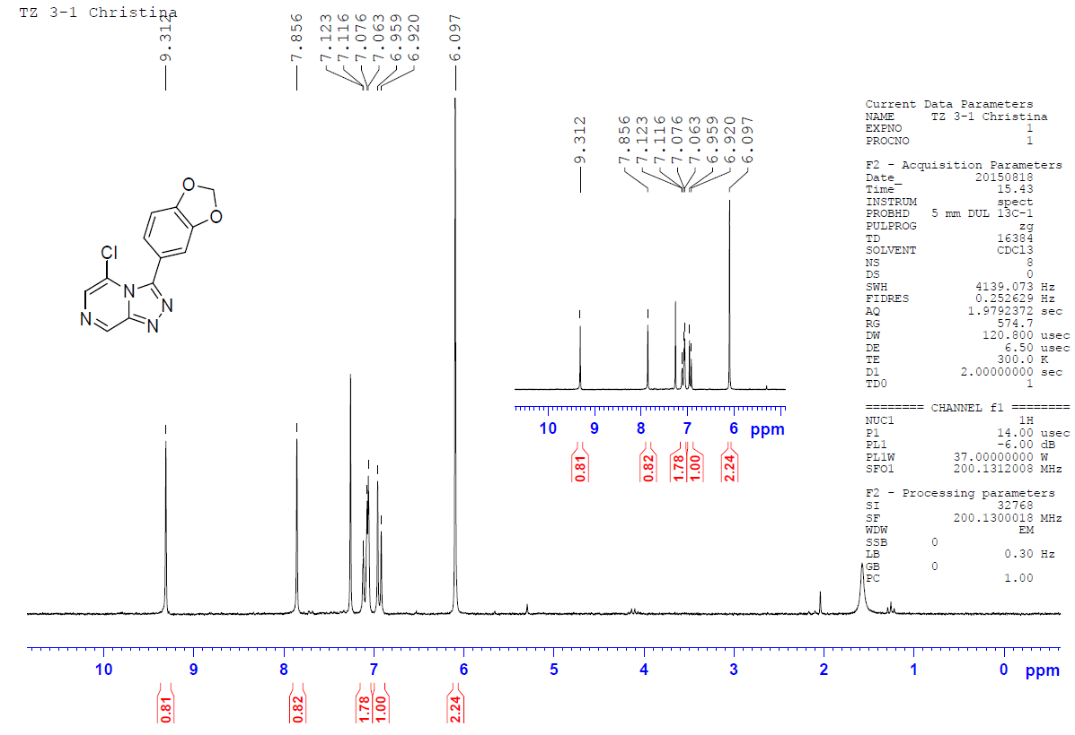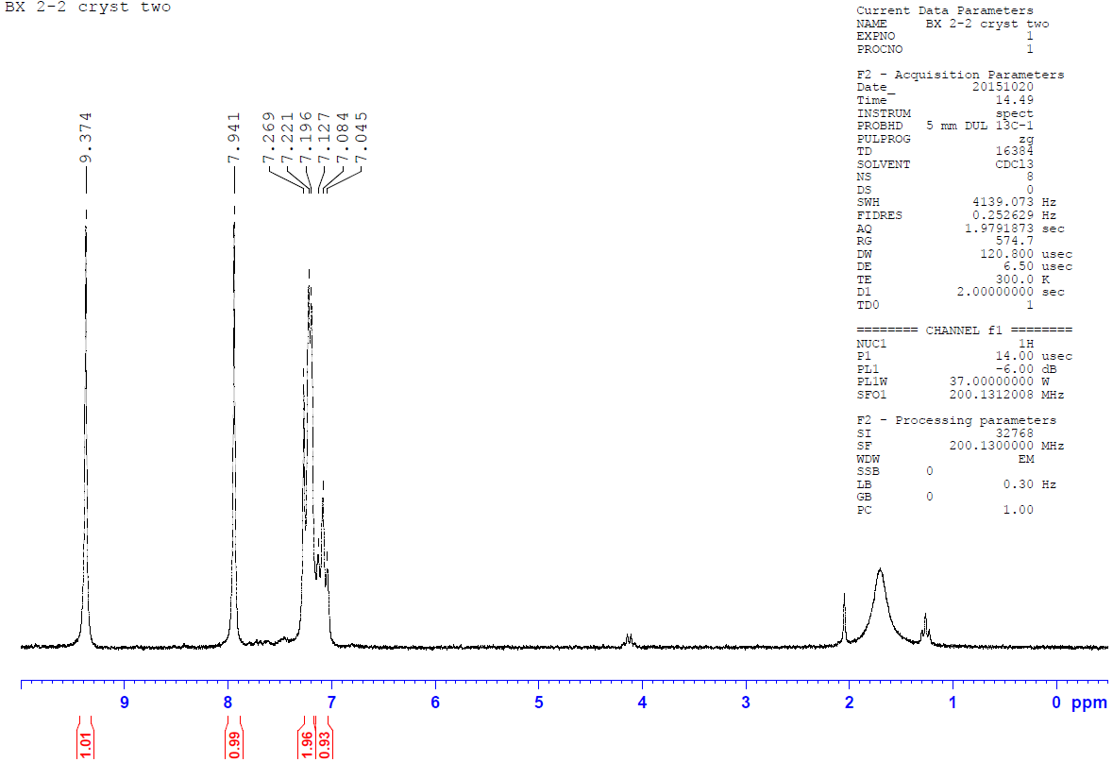**A - H NMR 5**

**B - H NMR 6**

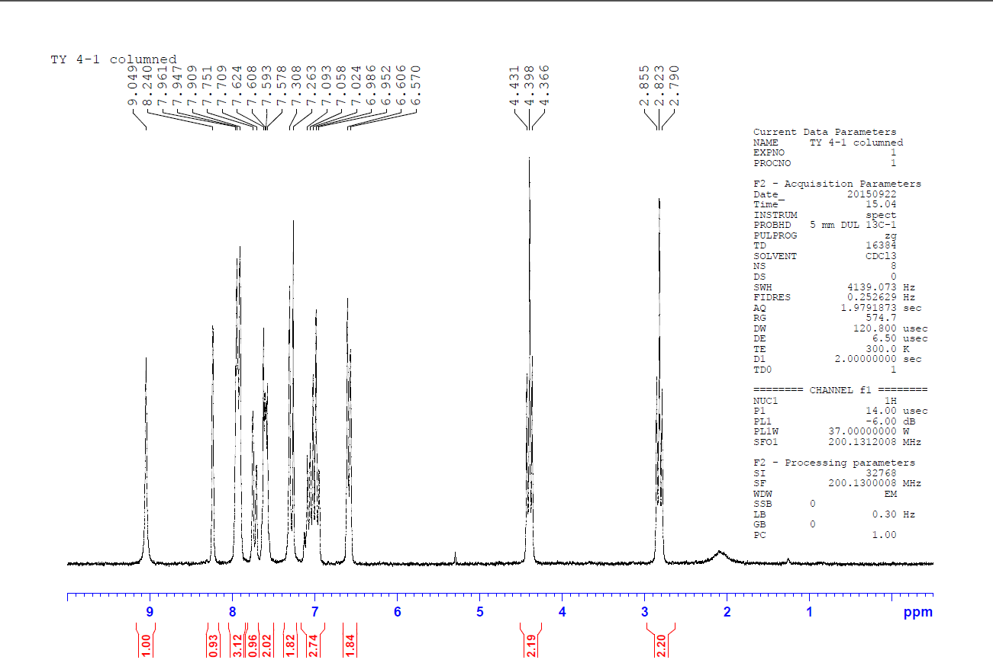**C - H NMR 7**

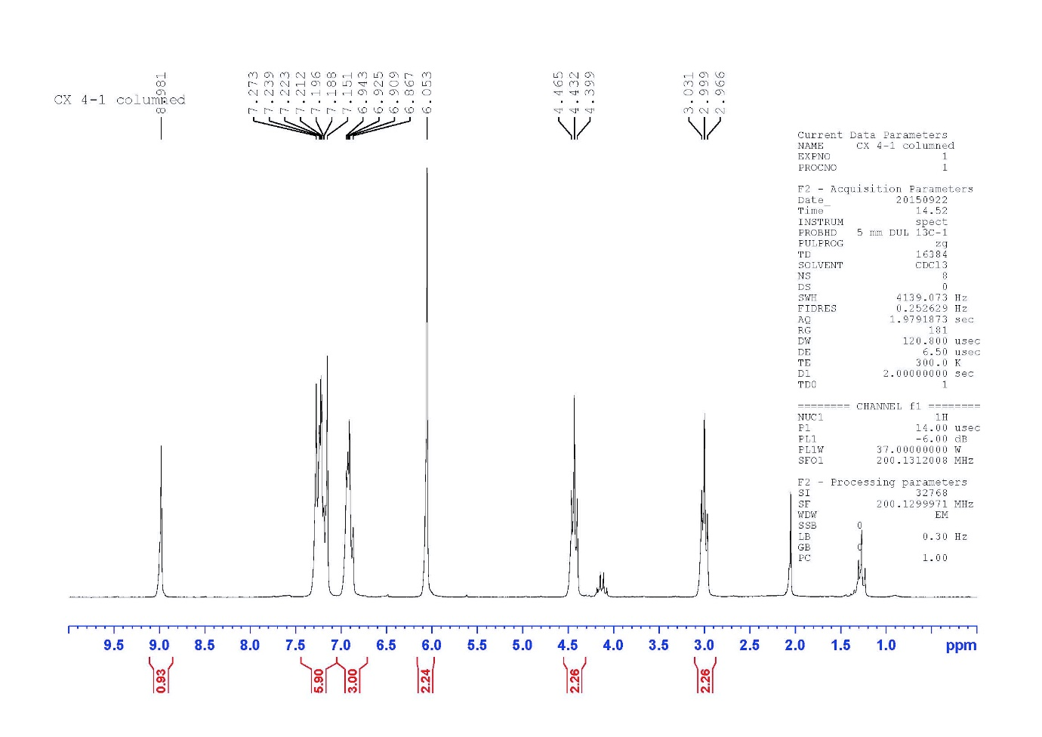**D - H NMR 8**

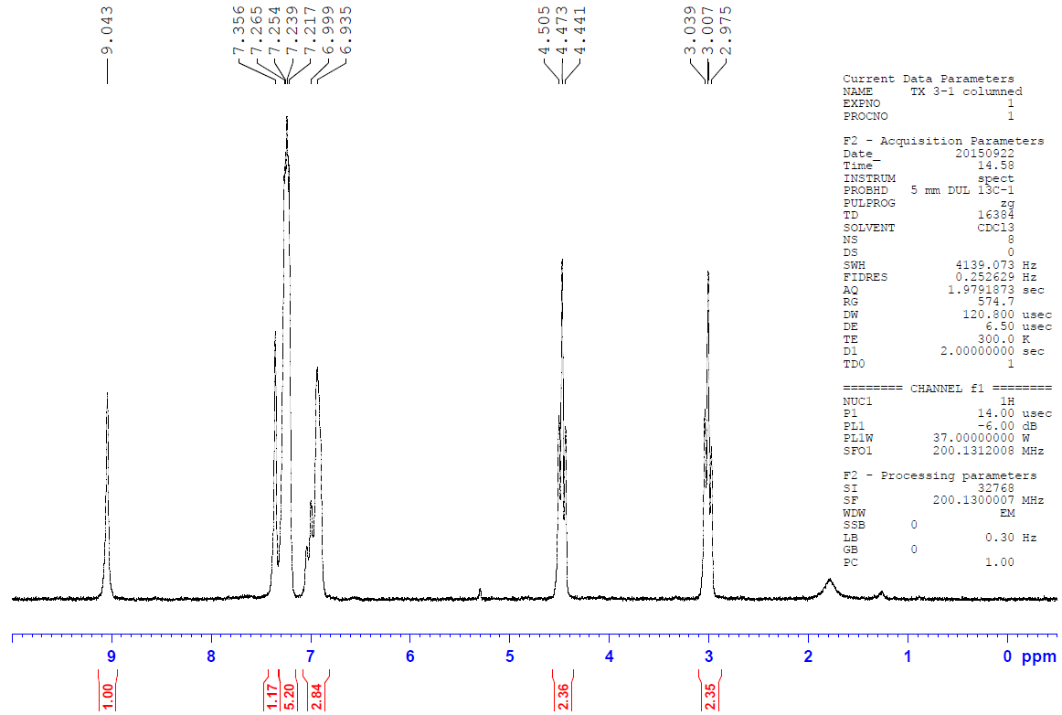**E - H NMR 9**

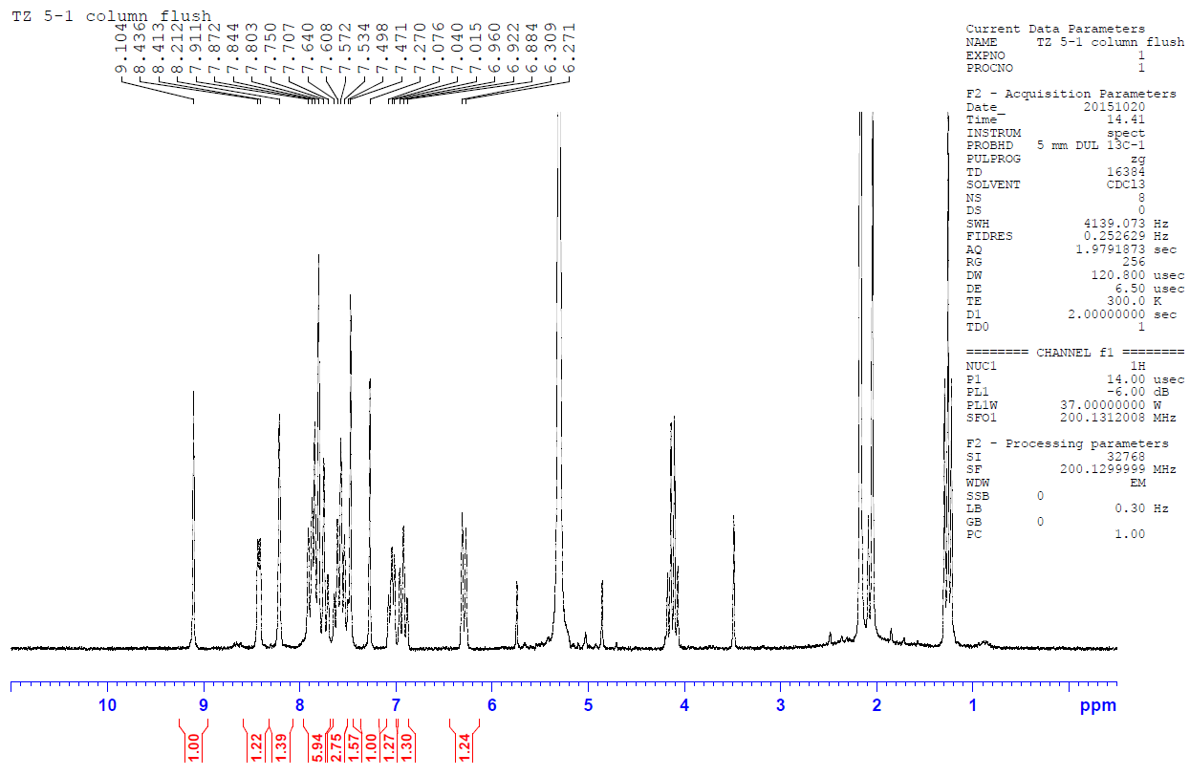**F - H NMR 10**

**G - H NMR 11**

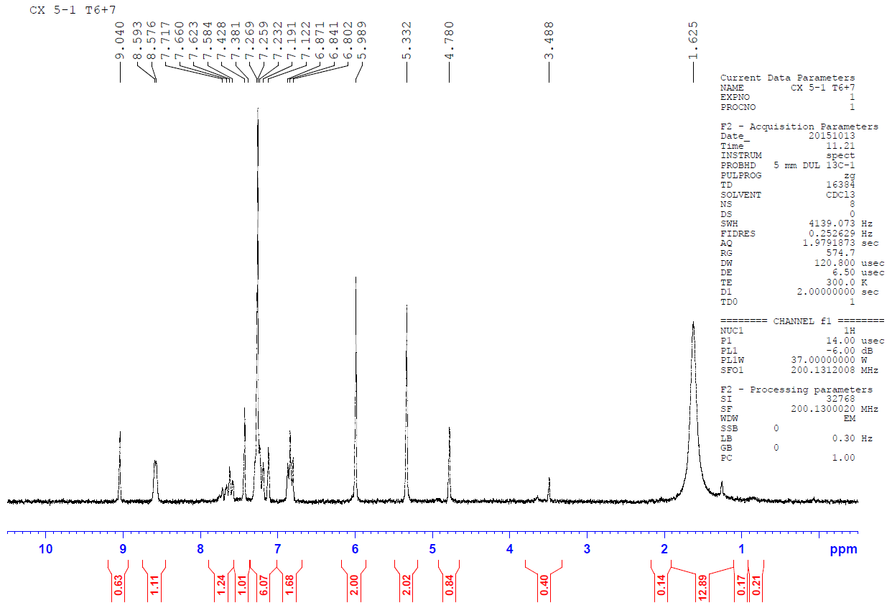

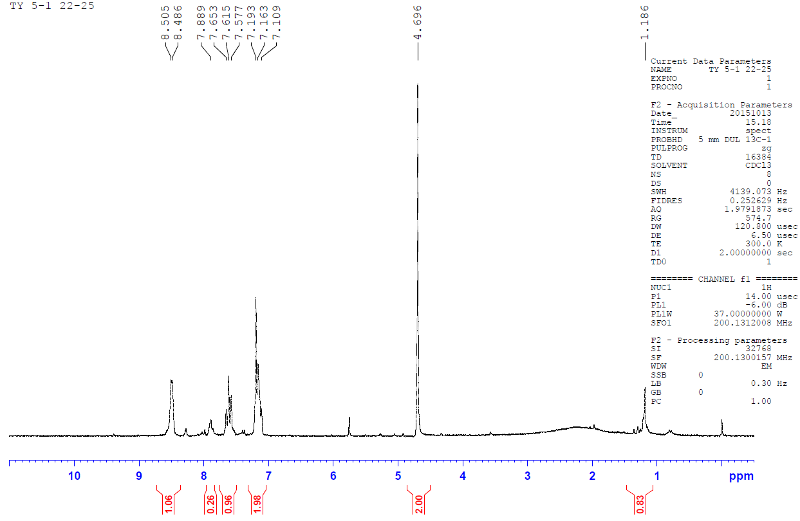**H - H NMR of column fractions of 10**